URIC ACID

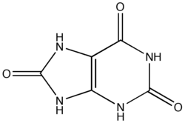

Mike Thompson & Anthony Woodman
Winchester College UK
Uric acid is a colourless, odourless and tasteless solid with molecular formula C₅H₄N₄O₃. Its systematic name is 2,6,8-trioxypurine. Historically it has been called lithic acid or 8-hydroxyxanthine?. Safety data on uric acid is unremarkable. It is largely insoluble in water. Rather than melt it decomposes in air above 250°C. Small amounts of uric acid are found in human urine as it is an excretory product at the end of nucleic acid metabolism of adenine and guanine.

Commercially uric acid has been prepared from guano by extracting it with alkali and then precipitating with acid. Guano is essentially the droppings of bats or seabirds and has been found in large quantities on some islands. It even got a mention in ‘Dr No’ by Ian Fleming.
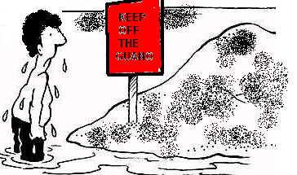

Uric acid forms salts
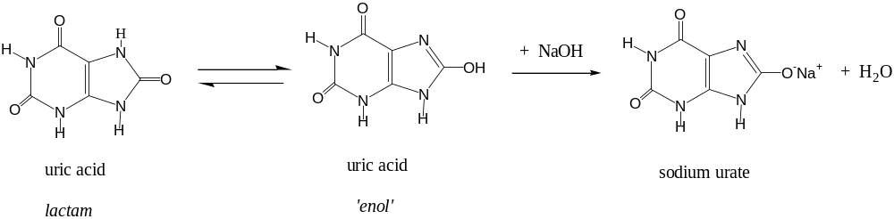
Figure 1

Uric acid is an acid because it is able to undergo a keto-enol tautomerism at physiological pH. Both of its rings are aromatic which allows the charge to be delocalised with the oxygen in the urate ion as shown in Figure 1.

Uric acid is a Purine

Adenine and guanine are probably two of the most famous purines as they are DNA bases. Figure 2 shows the similarity between caffeine and uric acid which are also purines. Caffeine is a well known chemical and is soon to have its own Molecule of the Month. Recent research suggests there may be health benefits for the brain in having daily caffeine. This is not too surprising since it is also known that uric acid at low levels is implicated in certain brain disorders. Higher levels of uric acid might be linked to longevity because of its strong antioxidant properties. In humans, about half of the blood’s anti-oxidative capacity is believed to be due to uric acid.

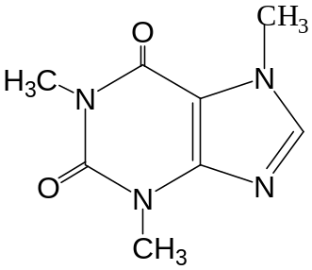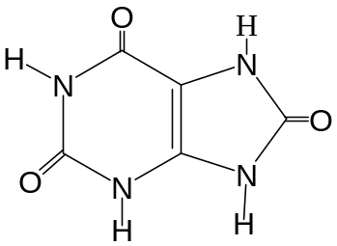

Caffeine uric acid

Figure 2
Low levels of uric acid in blood serum have also been linked to multiple sclerosis. Conversely high levels of uric acid have been associated with gout. Interestingly, a study of the medical records of 20 million U.K. patients’ showed that MS and gout occur almost entirely mutually exclusively. I know what I’d rather have….
Gout
Gout is a painful condition, and a form of arthritis, that causes inflammation of the joints. This happens more often in men over 40 and affects about 0.5% of the population. Gout has been recognised for over 2500 years since the time of the Greek physician Hippocrates. Gout was considered to be a disease of over-indulgence in food and alcohol, as it mostly afflicted the wealthy. It has been found that eating herring, sardines, heart or mussels may increase the level of uric acid. Famous gout sufferers have included; Alexander the Great, Henry VIII, Christopher Columbus, Leonardo da Vinci, Isaac Newton, John Milton and Alfred Lord Tennyson. Gout is usually associated with hyperuricemia where there are high uric acid concentrations in the blood. Gout is caused by the deposition of sodium urate (uric acid) crystals in the joints. The pain and inflammation is often found in the joint of the big toes as seen in Figure 3.

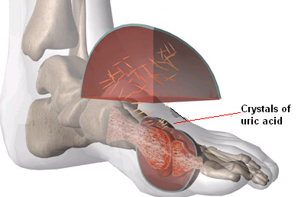
Figure 3
There are several detection methods for uric acid. A new method was reported in 2006 by the reported by the British Scientist David Parker which utilizes luminescent lanthanide complexes.

Figure 4 shows how one of the four DNA bases, guanine, is metabolised into uric acid via the intermediate xanthine.
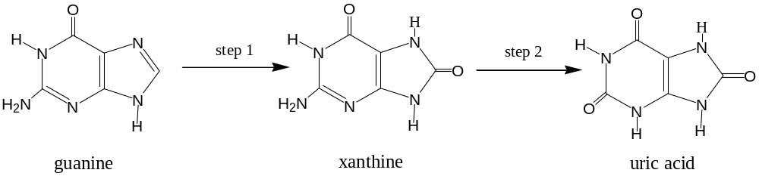
Figure 4

It is possible to treat gout with allopurinol a chemical which works by inhibiting xanthine oxidase the enzyme that produces uric acid from xanthine in step 2. The drug competes for the active site with xanthine and taking 100-300 mg each day of allopurinol usually works well to prevent gout attacks by reducing uric acid levels in the blood.
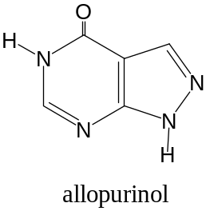
Uric acid in butterfly wings

Insects produce uric acid during protein breakdown (catabolism). The uric acid is not just excreted and has found some interesting uses. Uric acid helps to make butterflies iridescent. It also reflects the light produced in fireflies by bioluminescence in a similar way to mirrors in a car headlight.

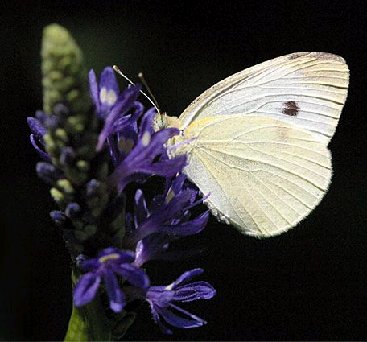  Cabbage white (Pieris rapae): the white colour comes from uric acid crystals in the epithelium. | 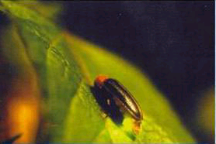  Fireflies make light in their abdomens to attract mates. This is achieved with luciferin. Light produced is then reflected away using crystals of uric acid. Luminol can be used in the laboratory to give a similar effect.

Uric acid in dalmations

The end of the metabolic pathway for most mammals is not uric acid but allantoin. This final transformation step 3 in Figure 5 takes place in the liver at the active site of the enzyme urate oxidase. Humans and curiously dalmations are a few of the mammals that do not possess this enzyme and they cannot oxidise uric acid to allantoin.

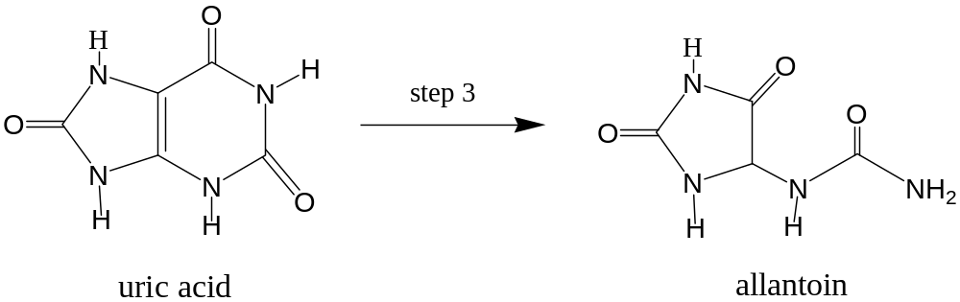

Figure 5

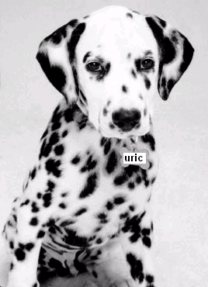 | Dalmations have accidentally lost the ability to metabolise uric acid through selective breeding.  Click either puppy for an optical illusion. Then press the help me 2 button.

Uric acid in the desert

The kangaroo rat is adapted to very dry environments and it is able to conserve water by producing uric acid. A complex metabolic pathway converts all amino acids to three other amino acids; glycine, glutamine or aspartic acid. These amino acids combine and are then degraded into uric acid. The payback for this costly operation is the conservation of water.

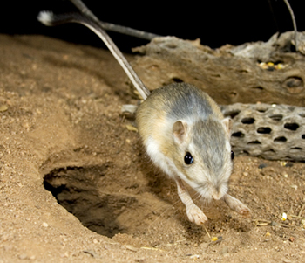
Amino acids are ultimately converted into uric acid to save water.
A useful piece of evolution for a desert dweller like the Kangaroo rat.

Pigments from Uric Acid

A wide variety of organisms make use of uric acid to produce pigments called pterins, e.g. xanthopterin, erythropterin & drosopterin. This class of molecules were first isolated from butterfly wings and were named from the Greek word pteron meaning wing. A whole range of colours have been achieved by subtle changes to the rings and the functional groups. An interesting article was written on this subject entitled “Insects, such as butterflies, wasps and ‘true bugs’ (heteroptera), cold-blooded vertebrates and even crustaceans do this” in Nature: March 4th 1950, 165, 367-8.

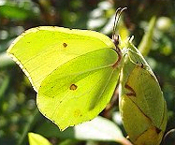 | 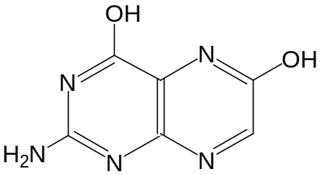
Brimstone butterfly | Xanthopterin = yellow

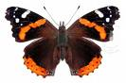 | 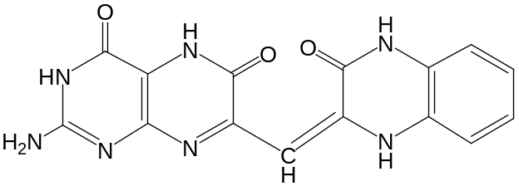
Red admiral | Erythropterin = orange / red

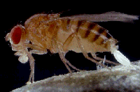 | 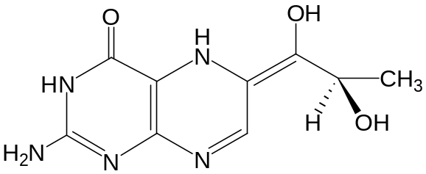
Fruit flies (drosphila) eyes | Drosopterin = red
Uric acid stones (kidney)
Elevated blood uric acid levels can also cause kidney disease and stones. In a few people the uric acid crystals form kidney stones.
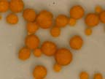
Allopurinol can be used to prevent uric acid kidney stones as well as gout.

Back to guano
Uric acid is combined in the form of urate of ammonia, and is the chief constituent of the urine of birds and reptiles, forming the white part. This helps to keep the birds weight down which is necessary for flight. Beware it can and does damage paint on cars as it is acidic. | 

